Deploy package using maven to tomcat:

Step 1: open the setting.xml file in M2_HOME/conf/setting.xml add below code

<server>

<id>name-id</id>

<username>tomcat-user-name</username>

<password> tomcat-password</password>

</server>

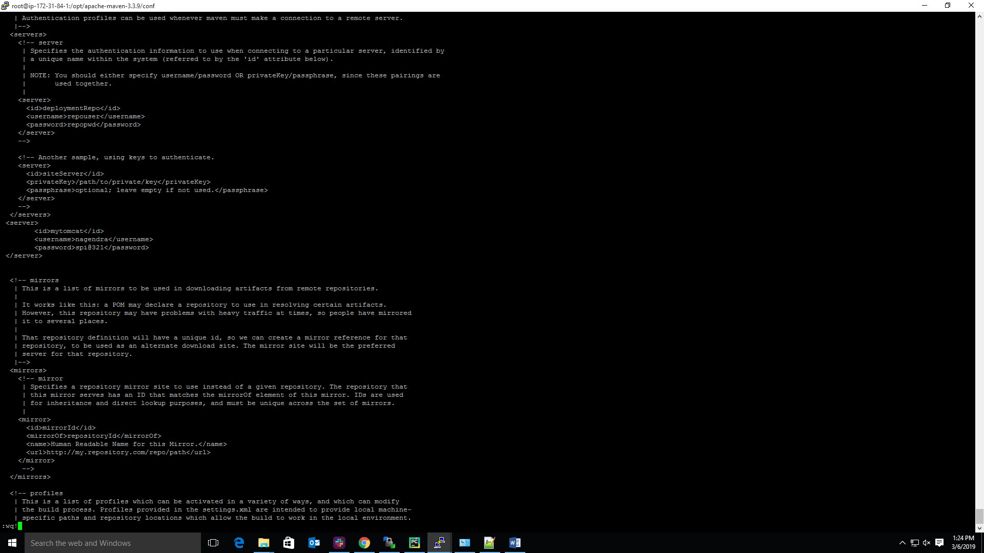

Step 2: Now, we need to add the blow code to POM.xml file

<plugin>

<groupId>org.apache.tomcat.maven</groupId>

<artifactId>tomcat7-maven-plugin</artifactId>

<version>2.2</version>

<configuration>

<url>http://3.84.221.216:8080/manager/text</url>

<server>mytomcat</server>

<path>/${project.build.finalName}</path>

</configuration>

</plugin>

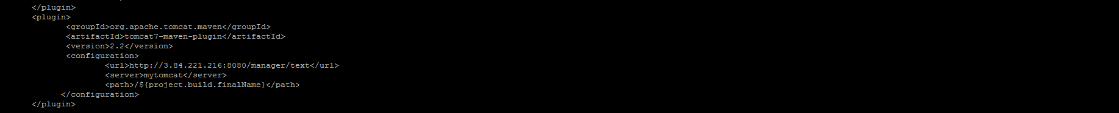

Step 3: Now, we need to create the setting.xml file at this path (vi ~/.m2/setting.xml) add the below code as shown below screen shot.

<servers>

<server>

<id>customize-name</id>

<username>admin</username>

<password>s3cret</password>

</server>



Step 4: Now we need to create the tomcat user at tomcat server side as shown below screen shot.

<tomcat-users>

<role rolename=” manager-script”/>

<user username=” admin” password=” s3cret” roles=” manager-script” />

</tomcat-users>

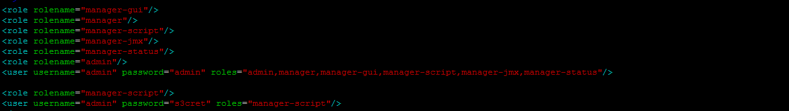

Step 5: now we need to run below command

>> mvn tomcat7:deploy 🡪 deploy the war file tomcat using maven